## **Whisper Down the Lane**

**Concept Document**

**Title Page**

The title page includes general information about the game:

* Game Name: Whisper Down The Lane.
* Game Logo: Tangled Phone Line.
* Game Catch Phrase: “We often hear how important communication is, but not what it is and how it affects our relationships. The issue of communication in our community is an important subject that needs our attention”.
* Document Type: Oculus Quest 2 APK and 3D 360 MP4.
* Document Version: 0.1

**Credit Page**

The credit page should present information about the person who authored the document and for what company.

* Document Purpose: Plan The Intentions of Whisper Down The Lane.
* Document Version: Draft.
* Working Title: Whisper Down The Lane.
* Game Concept: Linear Visual, Narrative Experience.
* Game Document Authors: Lyon Simic, Alexander Burton, Daniel Meakes and Jinhao Zhang.

**Sign-Off**

**GAME CONCEPT SIGN-OFF**

Lead Environment Artist: Lyon Simic

Lead Character Artist: Daniel Meakes

Lead Programmer: Alexander Burton

Lead Prop Artist: Jinhao Zhang

**Introduction**

• Genre: Linear Narrative.

• Player Type: VR First Person.

• Game Play: Press Play to Watch 360 Video From Start to Finish.

• Technical Form: Realtime VR and 3D 360 Video Player.

• Reference: 2D Whisper Down The Lane Source Material.

• Theme: Misunderstood Communication.

• Design Intentions: Transform the 2D Animated Message into a 3D 360 Experience.

**Game Analysis**

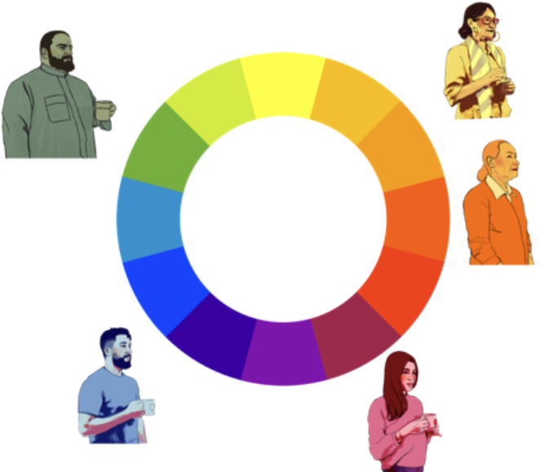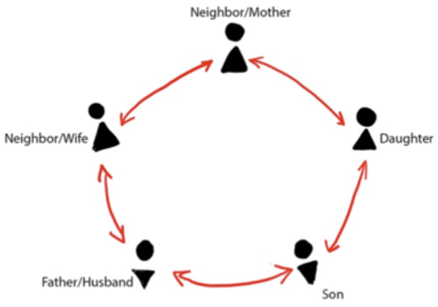

**Summary:**

* Involves a Group of Five Individuals.
* Camera Focuses on Two Characters at One Time.
* Total of 5 Interactions in a Playthrough.
* The Narrative Starts Positive and Relaxed from the First Phone Call.
* The “Neighbour/Wife” Starts with the Correct Information to “Neighbour/Mother”.
* “Neighbour/Mother” Relays the Information as Distorted Information to “Daughter”.
* “Daughter” sends the Distorted Information to “Son” .
* “Son” sends the Distorted Information to “Father/Husband”.
* “Father/Husband” ends with the Distorted Information back to “Neighbour/Wife”. who was originally joyful but ends up despondent due to misunderstanding.
* The Storyline then ends with a Furious and Angry Tone.
* The Phones Lines of Each Person Start Really Short but Become Longer in Length at the End to Signify People Have Become Distant and Silent.

**Game Description**

**Genre:**

* Linear Narrative.
* Visual Storytelling.
* Animation.
* Experimental.
* Drama.

**Game Elements:**

* Playable Video Experience.
* Watch the Narrative Scenario Play from Start to Finish.

**Game Content:**

* Linear VR Experience.
* Immersive Musical Soundtrack.
* Visual Cues of Colour Representing Calmness, Happiness and Rage.
* Observing Emotional Conversations Between Colorful Characters.

**Theme:**

* Misunderstood Communication.
* Transmission Chain Experiment.

**Art Style:**

* Rotoscoped.
* 2D Animation.
* Mixed Media.
* Distorted Black Outlines.
* Vibrant Colour Schemes.

**Game Sequence:**

* Player Launches Game.
* Start of Video has a Calm and Happy Atmosphere Between Characters.
* End of Video ends with Frustration from the Misunderstanding of the Original Information.

**Player:**

* Single Player Experience.

**Game Reference**

**Game Taxonomy:**

* Whisper Down The Lane is a Fictional Narrative Game, while This War of Mine is a Non-Fictional War Scenario Simulator Game.

**Player Immersion:**

* Linear.
* Focused.
* Narrative Driven.
* Emotional.
* Visually Beautiful.

**Reference:**

* Original 2D Source Material Provided by the Client.

**Game Technical**

**Technical Form:** • 2D graphics (Flat) and 3D graphics (Form)

**View:** • Fixed Camera.

**Platform:** • VR APK and 360 3D Video.

**Language:** • C#.

**Device:** • Oculus Quest 2, PC VR, Mobile and Online.

**Game Sales**

**Consumer Group:**

* 13-60 Year Olds.
* Teenagers, Adults and Seniors.

**Payment:**

* N/A.

**Estimated Price:**

* N/A.

**Game Atmosphere:**

* Calming.
* Joy.
* Rage.
* Despondent.

**Game Play:**

* Open Game.
* Clicking Play to Start the Character Conversation Sequences.
* Exit Game.

**Key Features:**

* Stunning Rotoscoped Art Style.
* Emotional Narrative.
* Colourful Characters.
* Believable Theme.
* Immersive 3rd Person Perspective.
* Accessible 3D 360 Video Support.
* Oculus Quest 2 Realtime Support.

**Selling Features:**

* N/A

**Design Document**

**Design Version:**

* Unity Version: 2021.3.14f1.
* Visual Studio 2022.
* Blender 3.4.

**Design Guidelines**

* Video Player Play, Pause and Restart UI Menu
* Whisper Down The Lane Video Player Component UV Sphere Projection

**Game Design Definitions**

* Pressing Play will Load the “Video Scene” with the Whisper Down The Lane Video Played on the Inverted Sphere Object.
* Pausing will freeze the “Video Scene” until the Player Clicks Play Again.
* Restart will Reload the “Video Scene” and the Whisper Down The Lane Video on the Inverted Sphere Object will be Played from the Start.

**Game Matrix**

* **“Player”** - First Person View with no Voice or Individual Body Mesh.
* **“Neighbour/Wife”** - First Character seen on the Video who is Coloured Orange and is Depicted as Older an Older Women who is Relaxed and Smokes Cigarettes.
* **“Neighbour/Mother”** - Second Character Displayed on the Video Coloured Yellow and is Portrayed Positively when Receiving the message but is then Quite Concerned when Passing on the Information.
* **“Daughter”** - Third Character is Shown on the Video Coloured Pink and has an Energetic, Confident Personality but then Becomes Frustrated when the Conversation Becomes Negative when Speaking to Son.
* **“Son”** - Fourth Character is Expressed on the Video Coloured Blue and Expels a Calming and Relaxed Aura but once Provoked by Daughter, he showcases Immense Frustration.
* **“Father/Husband”** - Fifth Character is Displayed in the Video Coloured Green and has an Authoritarian and Serious Attitude but Becomes more Angry the Longer he Talks to Son which Drives Him to Immediately Repeat the Information back to Neighbour/Wife from the Start which causes her Original Positive Expression Fall to Despair and Sadness.

**Game Flow Chart**

* Play Button

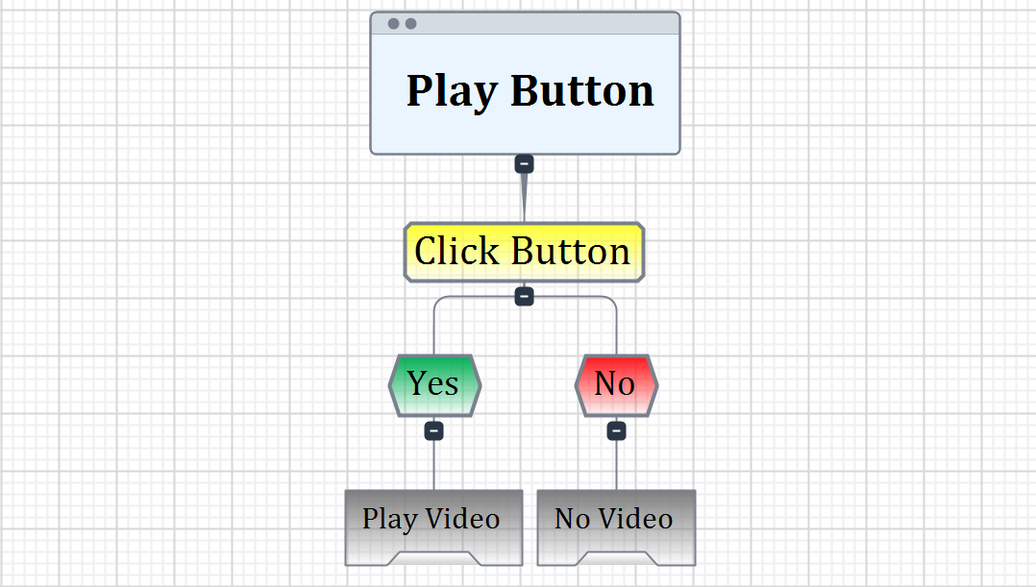

* Pause Button

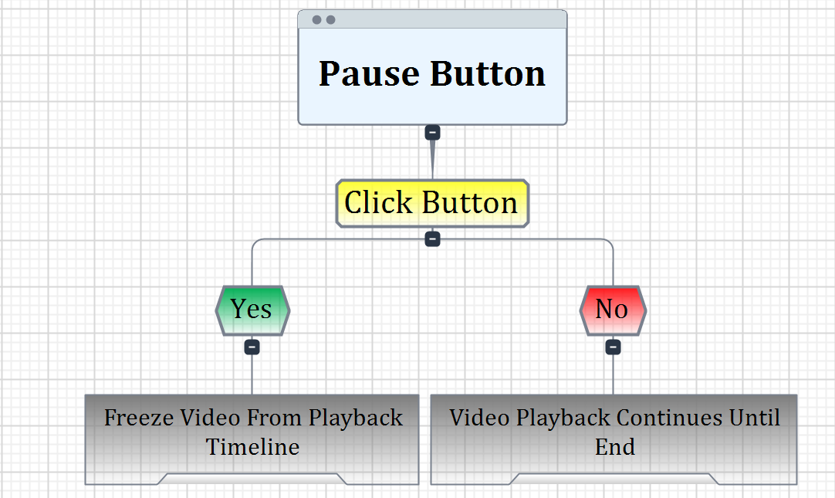

* Replay Button

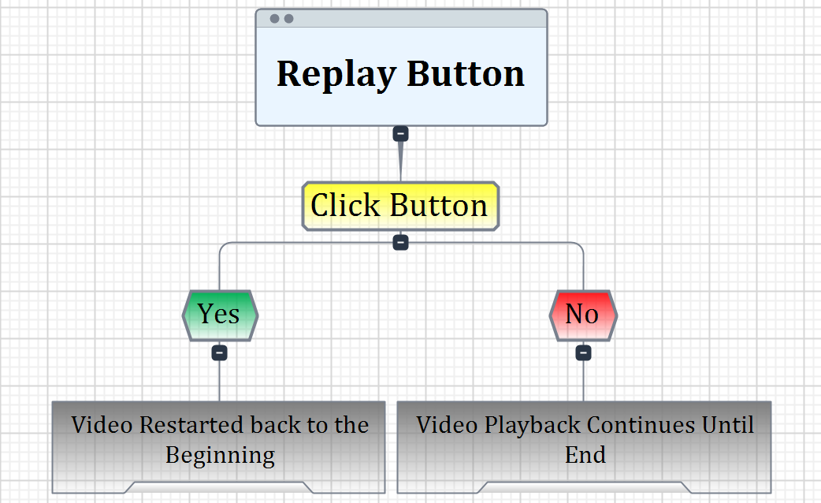

**Player Elements**

* **Default State:** Video Automatically Plays with Camera in the Centre of Sphere.
* **Actions List:** Video Playback, Pause, Play or Restart the Video.
* **Action1:** Video_Player.prefab - *“Video Player”*
* **Action2:** Play_Button.svg - *“Play"*
* **Action3:** Pause_Button.svg - *“Pause”*
* **Action4:** Replay_Button.svg - *“Replay”*
* **Information State:** Visual UI Buttons for Pausing, Playing or Restarting Video.
* **Default Properties:** Oculus Quest 2 Android URP Balanced Unity Graphics.
* **Winning:** Finish Entire Whisper Down The Lane Video.
* **Losing:** Fail to Finish Whisper Down The Lane Video Fully.

**Player Definition**

* Player Camera to View Whisper Down The Lane Video.

**User Interface (UI)**

* Whisper Down The Lane Application Startup UI

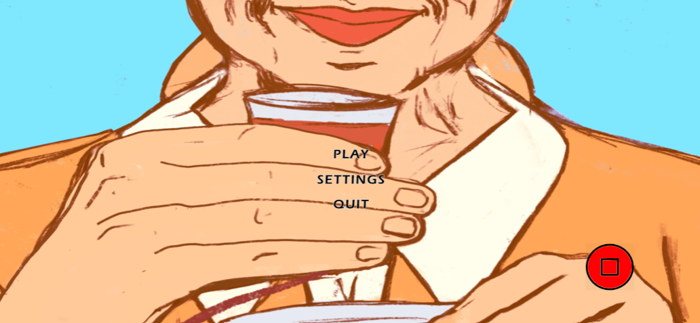

* VR Video Playback Player Controls UI

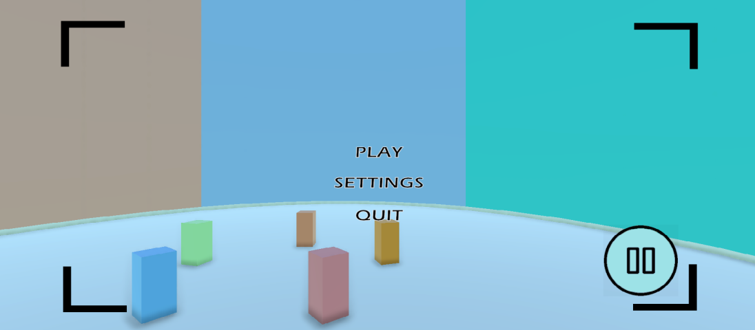

**Player View**

* Player VR First-Person View

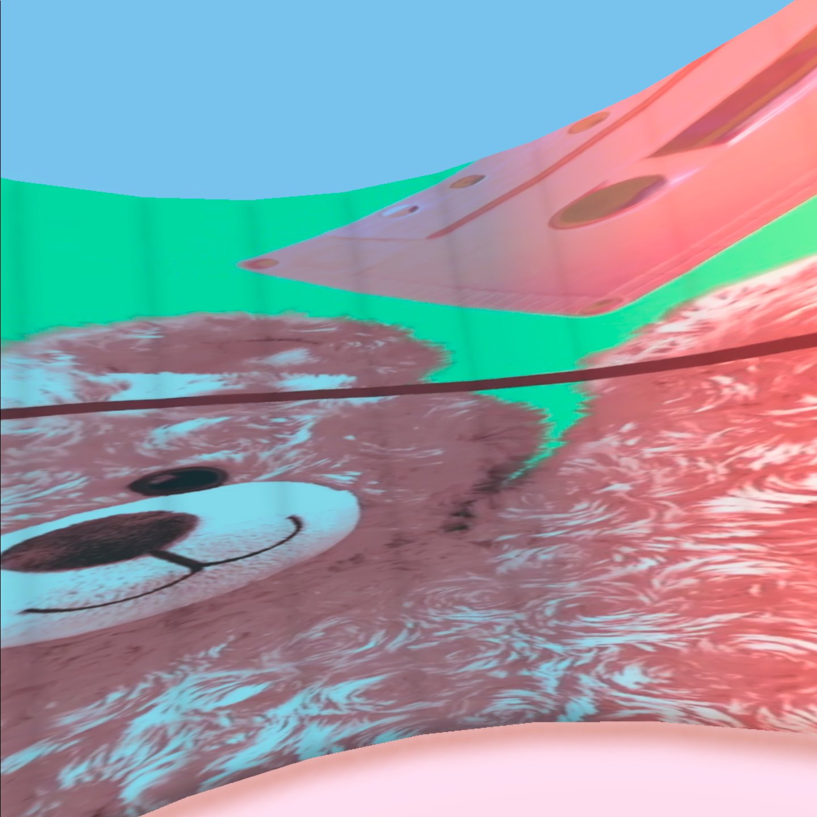

**Global Game Elements**

* Player Cannot Move Body/Head Position as App has Fixed Camera Views.

**The Story Elements**

* Whisper Down The Lane Visual Narrative Storyboard

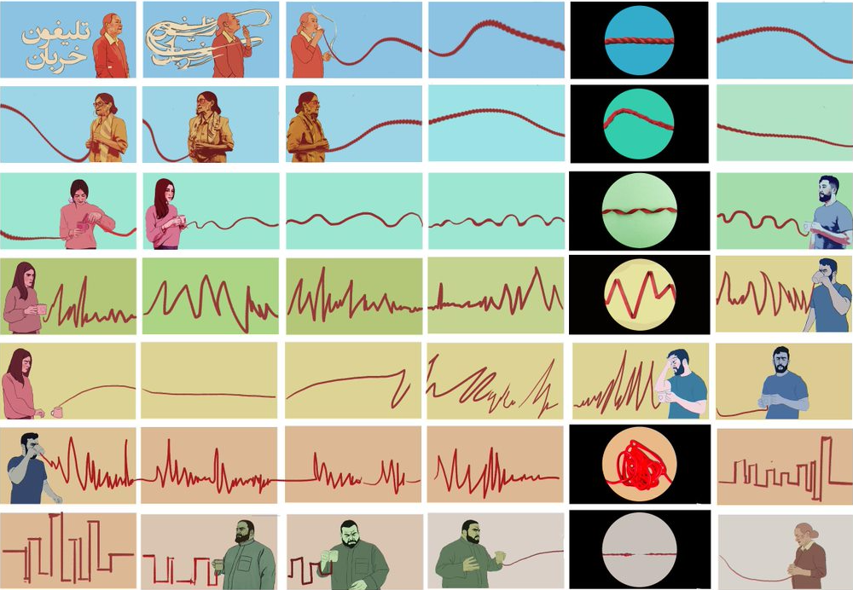

* Whisper Down The Lane Character and Colour Gradient Sheet

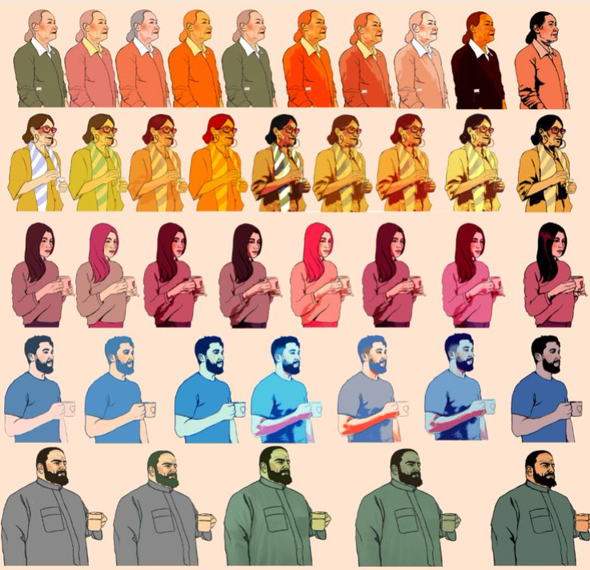

**The Story In-Game**

* The Story of Whisper Down The Lane is Unchanged in the Game Build as the Video Is being Transitioned Directly onto a 3D Inverted Sphere with the Unity Video Player Component.

**Level Design**

* Inverted Sphere for Displaying the 2D Whisper Down Lane Video in a 3D Space.

**Level Design In-Game**

* Sphere Created in Blender with Inverted Normals is Imported into Unity with the Player Camera Placed in the Centre of the Geometry.

**Audio & Sound F/X**

* **Music1:** Whisper_Down_The_Lane_Background.wav - *“Background Audio”*

**Game Architecture**

* Game Menu Structure

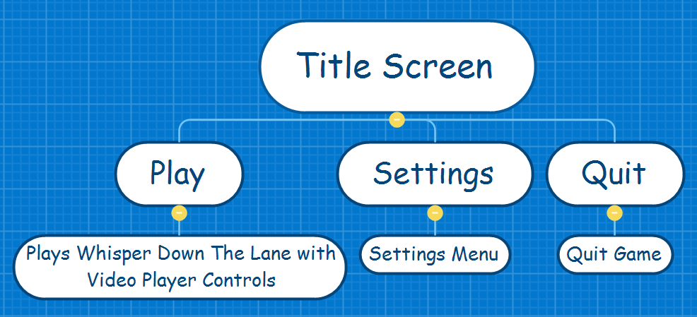

**Game Architecture Overview**

* Must Utilise the Same Font Type in the Whisper Down The Lane Video.
* Boxes Should have Rough, Scribbled Edges like in Rotoscoped Imagery.
* Colour Palettes Must Follow the Same Colour Gradient as Portrayed in the Video.
* Background Images Should Relate to the Whisper Down The Line Characters.

**Architecture In-Game Text Interface**

* *“Play”* - **Font:** WDTL/**Background:** Orange/**Outline:** Yes.
* *“Settings”* - **Font:** WDTL/**Background:** Yellow/**Outline:** Yes.
* *“Quit”* - **Font:** WDTL/**Background:** Green/**Outline:** Yes.
* *“Video Player Play”* - **Font:** WDTL/B**ackground:** Blue/**Outline:** No.
* *“Video Player Pause”* - **Font:** WDTL/**Background:** Pink/**Outline:** No.
* *“Video Player Restart”* - **Font:** WDTL/**Background:** Red/**Outline:** No.

**How To Play Game**

* Launch Game From Oculus Quest 2 Home Screen.
* Press the Play Button on the Startup UI Menu.

**Technical Documentation**

**Unity Pipeline:**

* Android Universal Render Pipeline.
* Balanced Renderer Settings.

**System Requirements:**

* Android.
* 6DOF Motion Tracking.
* 90Hz Refresh Rate.
* Oculus Quest.
* Oculus Quest 2.
* Meta Quest Pro.

**Visual Content**

**General**

* **File Size Restrictions:** 5GB
* **File Format Type:** MP4, PNG, SVG, WAV, PREFAB, SCENE, LIGHTING, RENDERTEXTURE, MAT, CS and FBX
* **File Quality Type:** High
* **Visual Scale:** 360 Degree View.  
  **Asset List:** 360_Inverted_Sphere.FBX and Whisper_Down_The_Lane.MP4.

**Player Elements**

* **Type of States:** Play, Pause and Restart.
* **Amount Animation Frames:** 24FPS.

**Heads Up Display (HUD)**

* **Type Icons:** Play(Triangle), Pause(Two Lines) and Restart(Clockwise Gapped Circle Arrow).
* **States:** Video Plays, Video Paused and Video Restarted.
* **Font Type:** Whisper Down The Lane.

**Global Elements**

* **Background/Texture/Tiles:** Whisper Down The Lane Video Playing.
* **Font Type:** Whisper Down The Lane.

**Audio Content**

**General**

* **File Size Restrictions:** 200MB.
* **File Format Type:** WAV.
* **File Quality Type:** High.
* **Asset List:** Whisper_Down_The_Lane_Background.WAV.

**Player Elements**

* **Type of Sound FX:** 360 Degree Channeled Orchestic Classical Background Music.

**Global Elements**

* **Ambient Music:** 360 Degree Channeled Orchestic Classical Background Music.

**Splash Screens**

* **Ambient Music:** Silence.

**Menus**

* **Type of Sound FX:** Phone Dail Number Sound.

**Programming Content**

**General**

* **Requirements:** Main Menu and Video Player Functionality.
* **File Size Restrictions:** 100MB.
* **File Format Type:** C#.
* **Specify Coding Conventions:** Using OnClick, TextMeshPro and UI.
* **Language/Device Restrictions:** None.
* **Screen Type:** Immersive 3D VR.

**Player Elements**

* **Type of Event:** OnClick UI Menu Actions and Video Playback Functionality.

**Global Elements**

* **Type of Event:** Menu Buttons and Video Playback Functions.

**Splash Screens**

* **Type of Event:** Nothing.

**Menus**

* **Type of Event:** OnClick.
* **Type of Options:** Play, Settings, Quit, Video Play, Video Pause and Video Restart.

**Code Structure**

* Using.
* Variables.
* Class.
* Void Update.
* Functions.

**Concerns and Alternatives**

* Texture Seams from Inverted Sphere - Blend Seam With Rotoscoped Outlines.
* Video Framerate Slowdown - Lower Resolution.

**Resources**

* Client Video Files.
* Client Audio Files.
* Client Character Design Files.
* Client Storyboards.

**Technical Matrix**

**Oculus Quest 2**

**Art**

* Inverted Sphere.
* Video Material.
* Video Render Texture.
* VR Camera.

**Audio**

* Whisper Down The Lane Background Music.
* Button Click Phone Dail Tone Sound.

**Programming**

* OnClick Events.
* Scene Management.

**User Interface**

* Main Menu.
* Video Player Functions.